Oblique Triangular Pyramid
# Source: AI Source: Provided by: [Data Path: Persons Table -> ID Column: 1, Name_En Column: Motasem Essam] -> From: [ChatGPT] on [7/25/2026]
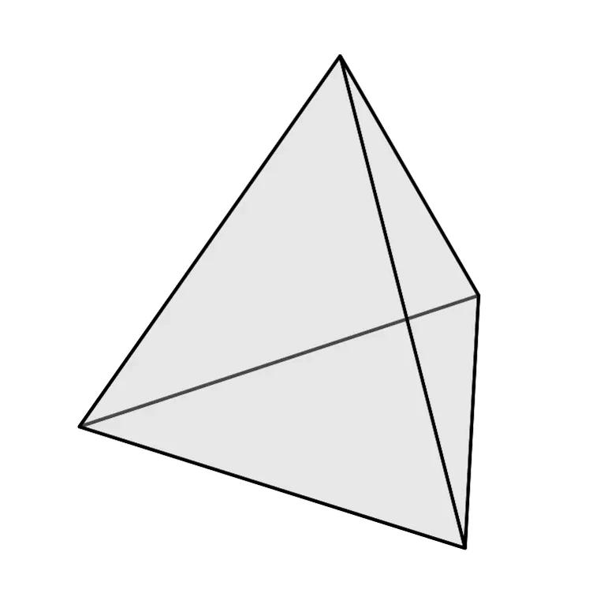

Definition
# Source: AI Source: Provided by: [Data Path: Persons Table -> ID Column: 1, Name_En Column: Motasem Essam] -> From: [ChatGPT] on [7/25/2026]
An oblique triangular pyramid is a three-dimensional polyhedron with a triangular base and three triangular lateral faces, in which the perpendicular projection of the apex onto the base plane does not meet the designated center of the base.
Unlike a right triangular pyramid, the apex is displaced sideways relative to the base center. Consequently, the lateral edges and lateral faces may have different lengths, shapes, and areas.
The perpendicular height is still measured at a right angle to the plane of the base, even when its foot lies away from the center or outside the triangular base.
Important: Oblique describes the spatial position of the apex relative to the base. It does not mean that the pyramid's height is slanted; the height is always perpendicular to the base plane.

Simple Definition
# Source: AI Source: Provided by: [Data Path: Persons Table -> ID Column: 1, Name_En Column: Motasem Essam] -> From: [ChatGPT] on [7/25/2026]
An oblique triangular pyramid is a triangular pyramid whose apex is not directly above the designated center of its triangular base.

Key Characteristics
# Source: AI Source: Provided by: [Data Path: Persons Table -> ID Column: 1, Name_En Column: Motasem Essam] -> From: [ChatGPT] on [7/25/2026]
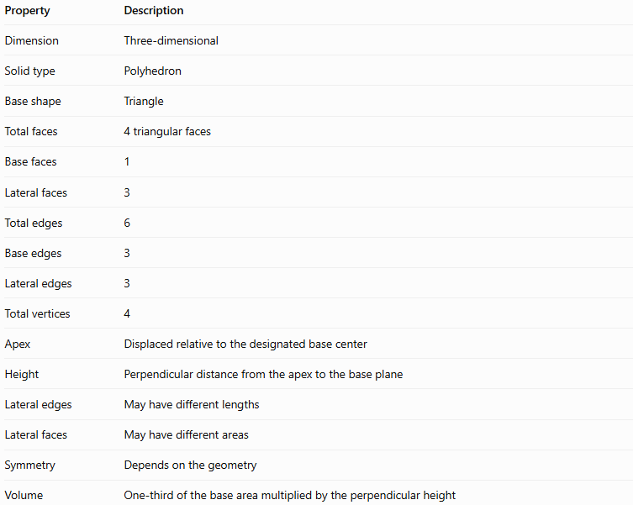
Property | Description
Dimension | Three-dimensional
Solid type | Polyhedron
Base shape | Triangle
Total faces | 4 triangular faces
Base faces | 1
Lateral faces | 3
Total edges | 6
Base edges | 3
Lateral edges | 3
Total vertices | 4
Apex | Displaced relative to the designated base center
Height | Perpendicular distance from the apex to the base plane
Lateral edges | May have different lengths
Lateral faces | May have different areas
Symmetry | Depends on the geometry
Volume | One-third of the base area multiplied by the perpendicular height

Geometric Representation
# Source: AI Source: Provided by: [Data Path: Persons Table -> ID Column: 1, Name_En Column: Motasem Essam] -> From: [ChatGPT] on [7/25/2026]
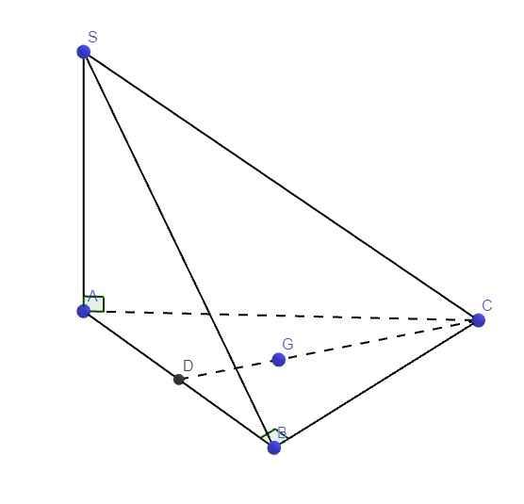
The main components are:
- Triangular base $ABC$: The triangle forming the base of the pyramid.
- Apex $S$: The vertex that connects to all three base vertices.
- Base center $G$: The designated center of the base triangle, such as its centroid.
- Perpendicular height $h$: The perpendicular distance from $S$ to the plane containing $ABC$.
- Base edges $AB$, $BC$, and $CA$: The three edges around the base.
- Lateral edges $SA$, $SB$, and $SC$: The edges joining the apex to the base vertices.
- Lateral faces $SAB$, $SBC$, and $SCA$: The three triangular side faces.
The defining relationship is that the perpendicular projection of $S$ onto the base plane does not coincide with $G$.
If the foot of the perpendicular is $H$, then:
$$SH⊥\text{plane}\left(ABC\right)$$
and, for an oblique pyramid under the stated convention,
$$H≠G$$
The foot $H$ may lie inside or outside the triangular base, depending on the pyramid's geometry.

Mathematical Representations and Formulas
# Source: AI Source: Provided by: [Data Path: Persons Table -> ID Column: 1, Name_En Column: Motasem Essam] -> From: [ChatGPT] on [7/25/2026]
Let:
- $B$ = area of the triangular base.
- $h$ = perpendicular height of the pyramid.
- $A_{T}$ = total surface area.
- $A_{L}$ = lateral surface area.
- $P_{b}$ = perimeter of the base.

Number of faces, edges, and vertices
# Source: AI Source: Provided by: [Data Path: Persons Table -> ID Column: 1, Name_En Column: Motasem Essam] -> From: [ChatGPT] on [7/25/2026]
For a pyramid with an $n$-sided base:
$$F=n+1, E=2n, V_{e}=n+1$$
For a triangular pyramid, $n=3$:
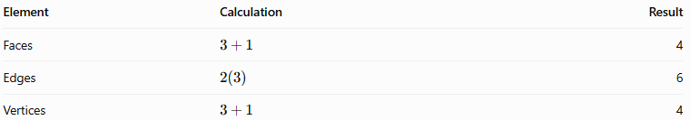
Element | Calculation | Result
Faces | $$3+1$$ | 4
Edges | $$2\left(3\right)$$ | 6
Vertices | $$3+1$$ | 4
Euler's formula for convex polyhedra is:
$$V_{e}-E+F=2$$
Substituting:
$$4-6+4=2$$
Therefore, an oblique triangular pyramid satisfies Euler's formula.

Volume
# Source: AI Source: Provided by: [Data Path: Persons Table -> ID Column: 1, Name_En Column: Motasem Essam] -> From: [ChatGPT] on [7/25/2026]
The volume of an oblique triangular pyramid is:
$$\boxed{V=\frac{1}{3}Bh}$$
If the triangular base has base length $b$ and perpendicular altitude $h_{b}$, then:
$$B=\frac{1}{2}{bh}_{b}$$
Thus:
$$\boxed{V=\frac{1}{6}{bh}_{b}h}$$
The height $h$ must be perpendicular to the base plane. A slanted lateral edge must not be substituted for this height.

Total surface area
# Source: AI Source: Provided by: [Data Path: Persons Table -> ID Column: 1, Name_En Column: Motasem Essam] -> From: [ChatGPT] on [7/25/2026]
The total surface area is the sum of the areas of the base and the three lateral faces:
$$\boxed{A_{T}=B+A_{1}+A_{2}+A_{3}}$$
The lateral surface area is:
$$\boxed{A_{L}=A_{1}+A_{2}+A_{3}}$$
Because an oblique pyramid generally has differently inclined lateral faces, their areas should be calculated separately. The simplified formula
$$A_{L}=\frac{1}{2}P_{b}l$$
is valid only when all lateral faces have the same applicable slant height $l$, as in a regular right pyramid, not for an arbitrary oblique triangular pyramid.

Calculating a lateral edge
# Source: AI Source: Provided by: [Data Path: Persons Table -> ID Column: 1, Name_En Column: Motasem Essam] -> From: [ChatGPT] on [7/25/2026]
Let $H$ be the foot of the perpendicular from apex $S$ to the base plane. For any base vertex $A$, triangle $SHA$ is right-angled at $H$.
By the Pythagorean theorem:
$$\boxed{SA=\sqrt{SH^{2}+HA^{2}}}$$
Similarly:
$$SB=\sqrt{SH^{2}+HB^{2}}$$
$$SC=\sqrt{SH^{2}+HC^{2}}$$
Since $HA$, $HB$, and $HC$ may differ, the three lateral edges may have different lengths.

Worked Examples
# Source: AI Source: Provided by: [Data Path: Persons Table -> ID Column: 1, Name_En Column: Motasem Essam] -> From: [ChatGPT] on [7/25/2026]
Example 1: Identifying the elements
An oblique triangular pyramid has a triangular base. Determine its number of faces, edges, and vertices.
Solution:
- Faces: $3+1=4$
- Edges: $2\left(3\right)=6$
- Vertices: $3+1=4$
Answer: 4 faces, 6 edges, and 4 vertices.
Example 2: Calculating volume
An oblique triangular pyramid has a base triangle with base $10\text{ cm}$ and perpendicular altitude $6\text{ cm}$. The perpendicular height of the pyramid is $12\text{ cm}$.
Step 1: Calculate the base area.
$$B=\frac{1}{2}\left(10\right)\left(6\right)=30{\text{ cm}}^{2}$$
Step 2: Calculate the volume.
$$V=\frac{1}{3}\left(30\right)\left(12\right)$$
$$\boxed{V=120{\text{ cm}}^{3}}$$
Answer: The volume is $120{\text{ cm}}^{3}$.
Example 3: Calculating a lateral edge
Suppose the perpendicular height $SH$ is $8\text{ cm}$, and the distance from the foot of the height to base vertex $A$ is $6\text{ cm}$.
Using the Pythagorean theorem:
$$SA=\sqrt{8^{2}+6^{2}}$$
$$SA=\sqrt{64+36}=\sqrt{100}$$
$$\boxed{SA=10\text{ cm}}$$
Answer: The lateral edge $SA$ is $10\text{ cm}$.

Comparison with Related Concepts
# Source: AI Source: Provided by: [Data Path: Persons Table -> ID Column: 1, Name_En Column: Motasem Essam] -> From: [ChatGPT] on [7/25/2026]
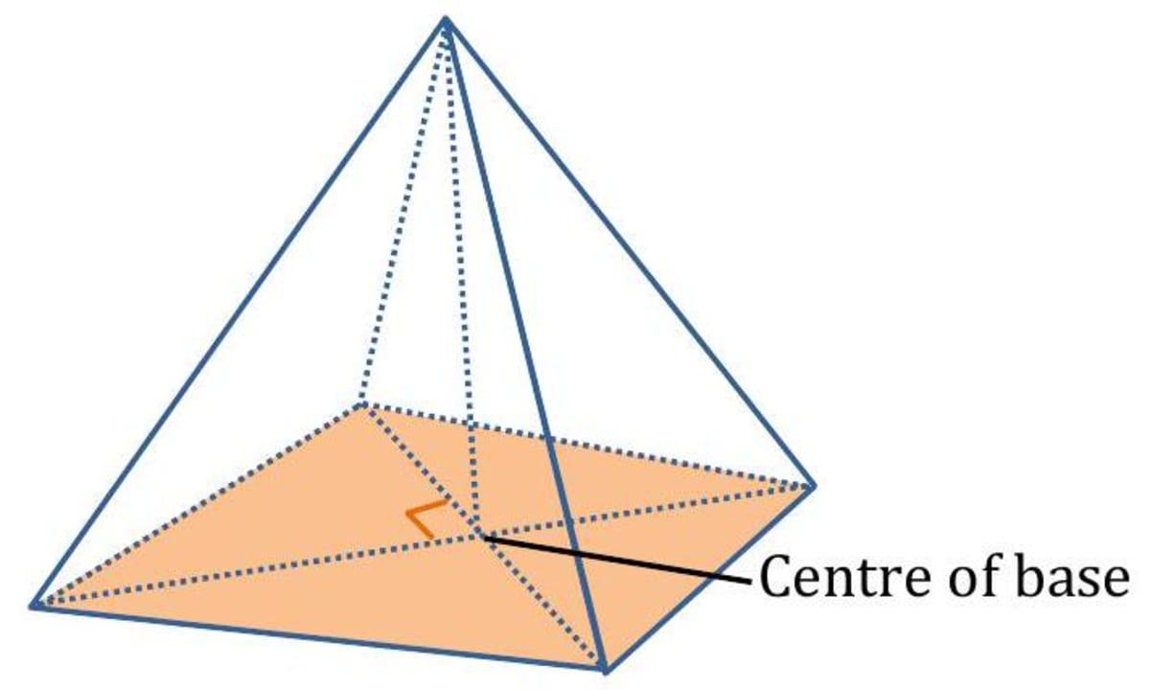
Right Triangular Pyramid
The apex is directly above the designated center of the triangular base. Its perpendicular height meets the base at that center.
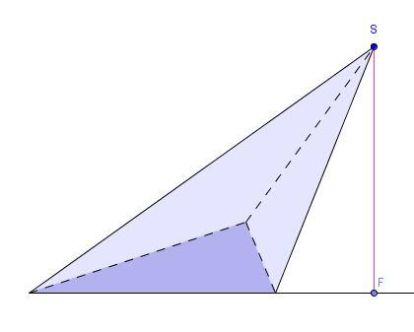
Oblique Triangular Pyramid
The apex is displaced relative to the designated base center. The perpendicular height still meets the base plane at ${90}^{∘}$.
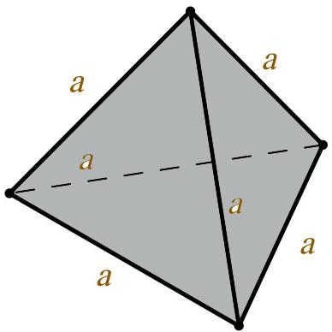
Regular Tetrahedron
All four faces are congruent equilateral triangles, and all six edges are equal. Its apex is above the center of an equilateral base.
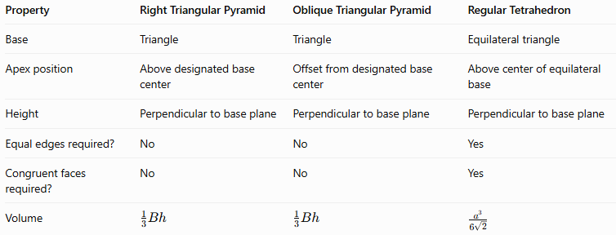
Property | Right Triangular Pyramid | Oblique Triangular Pyramid | Regular Tetrahedron
Base | Triangle | Triangle | Equilateral triangle
Apex position | Above designated base center | Offset from designated base center | Above center of equilateral base
Height | Perpendicular to base plane | Perpendicular to base plane | Perpendicular to base plane
Equal edges required? | No | No | Yes
Congruent faces required? | No | No | Yes
Volume | $$\frac{1}{3}Bh$$ | $$\frac{1}{3}Bh$$ | $$\frac{a^{3}}{6\sqrt{2}}$$

Applications
# Source: AI Source: Provided by: [Data Path: Persons Table -> ID Column: 1, Name_En Column: Motasem Essam] -> From: [ChatGPT] on [7/25/2026]
- Architecture: Modeling sloping roof structures and asymmetric pyramid forms.
- Engineering: Representing solid components with triangular bases and offset apexes.
- Computer graphics: Constructing asymmetric tetrahedral meshes and three-dimensional models.
- Finite element analysis: Dividing complex three-dimensional objects into tetrahedral elements.
- Geometry education: Understanding spatial orientation, perpendicular height, and the distinction between height and lateral edges.

Key Points
# Source: AI Source: Provided by: [Data Path: Persons Table -> ID Column: 1, Name_En Column: Motasem Essam] -> From: [ChatGPT] on [7/25/2026]
- An oblique triangular pyramid has four triangular faces, six edges, and four vertices.
- Its apex is displaced relative to the designated center of the base.
- Its perpendicular height remains at ${90}^{∘}$ to the base plane.
- Its base triangle does not have to be a right triangle.
- Its lateral edges and lateral faces may have different dimensions.
- Its volume is $V=\frac{1}{3}Bh$.
- Its total surface area is the sum of the areas of its four triangular faces.
- Its perpendicular height is different from its slanted lateral edges.
- Its geometry may be asymmetric, but obliqueness alone does not determine every aspect of its symmetry.

Conclusion
# Source: AI Source: Provided by: [Data Path: Persons Table -> ID Column: 1, Name_En Column: Motasem Essam] -> From: [ChatGPT] on [7/25/2026]
An oblique triangular pyramid is a triangular pyramid whose apex is not directly above the designated center of its base. Its defining characteristic is the offset position of the apex, while its height remains perpendicular to the base plane.
Although its four faces are triangular, its lateral faces and edges may have different dimensions. Its volume is calculated using one-third of the base area multiplied by the perpendicular height, and its total surface area is found by adding the areas of all four faces. This makes the oblique triangular pyramid an important example for understanding spatial orientation and the geometry of nonuniform polyhedra.

